# PL/SQL Week 2 Exercises

## Exercise 1: Control Structures

### Scenario 1: Discount for Seniors

BEGIN  
 FOR customer IN (SELECT customer_id, age FROM customers) LOOP  
 IF customer.age > 60 THEN  
 UPDATE loans  
 SET interest_rate = interest_rate - 1  
 WHERE customer_id = customer.customer_id;  
 END IF;  
 END LOOP;  
END;

## Output

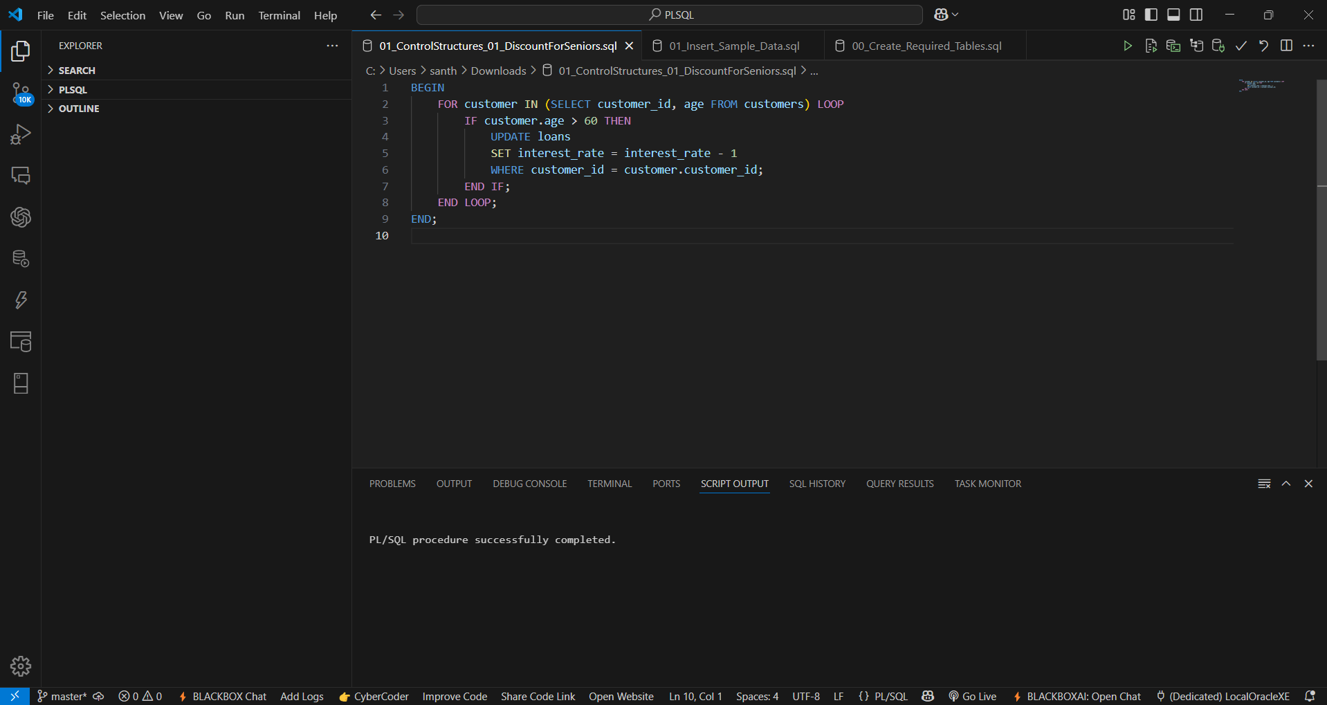

### Scenario 2: VIP Promotion

BEGIN  
 FOR customer IN (SELECT customer_id, balance FROM customers) LOOP  
 IF customer.balance > 10000 THEN  
 UPDATE customers  
 SET IsVIP = 'TRUE'  
 WHERE customer_id = customer.customer_id;  
 END IF;  
 END LOOP;  
END;

## Output

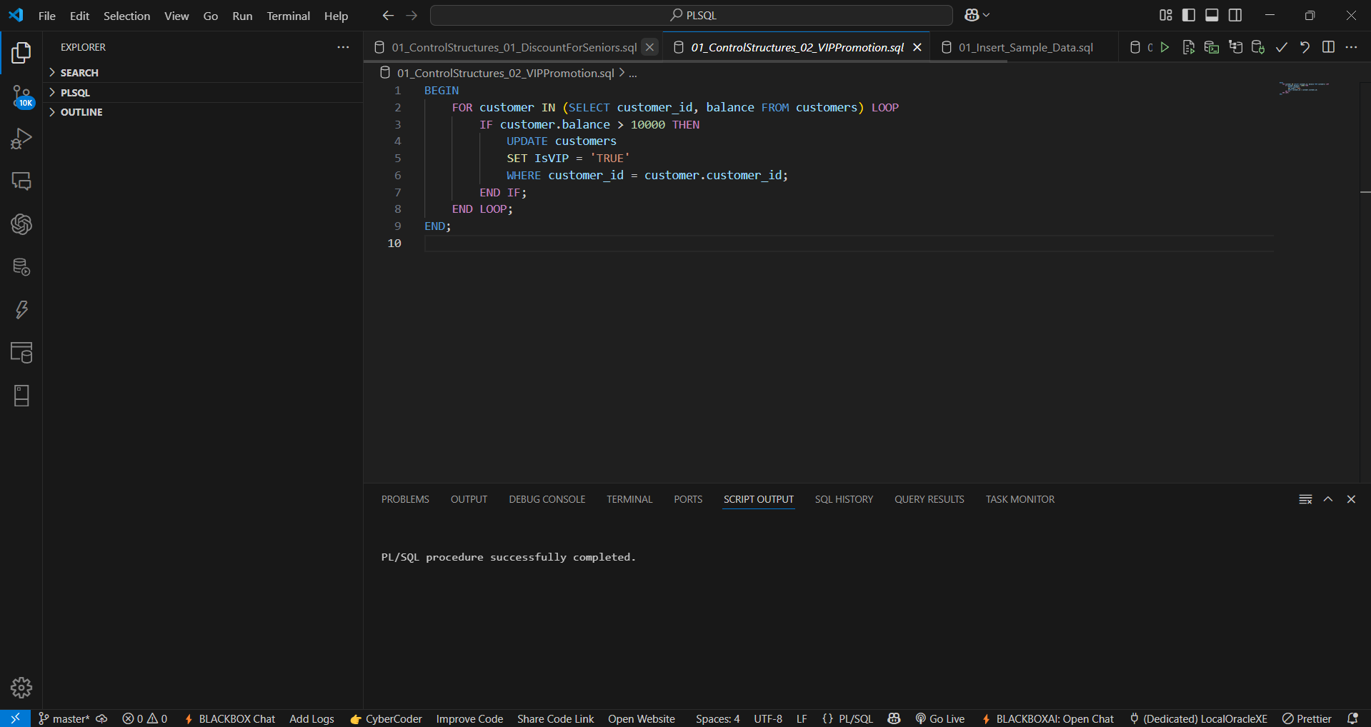

### Scenario 3: Loan Reminders

BEGIN  
 FOR loan IN (SELECT customer_id, due_date FROM loans WHERE due_date <= SYSDATE + 30) LOOP  
 DBMS_OUTPUT.PUT_LINE('Reminder: Loan for Customer ' || loan.customer_id || ' is due on ' || loan.due_date);  
 END LOOP;  
END;

## Output

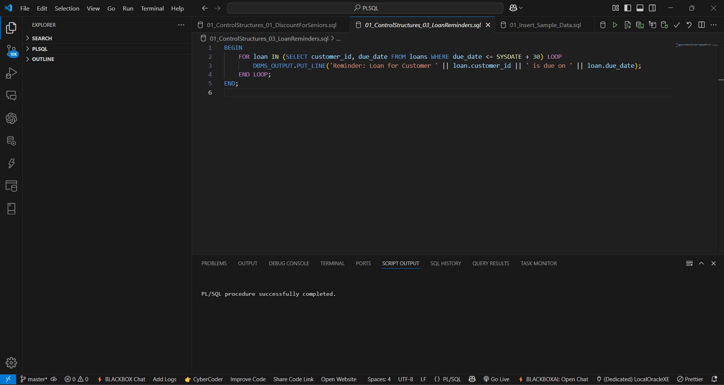

## Exercise 3: Stored Procedures

### Scenario 1: Process Monthly Interest

CREATE OR REPLACE PROCEDURE ProcessMonthlyInterest IS  
BEGIN  
 UPDATE savings_accounts  
 SET balance = balance + (balance * 0.01);  
END;

## Output

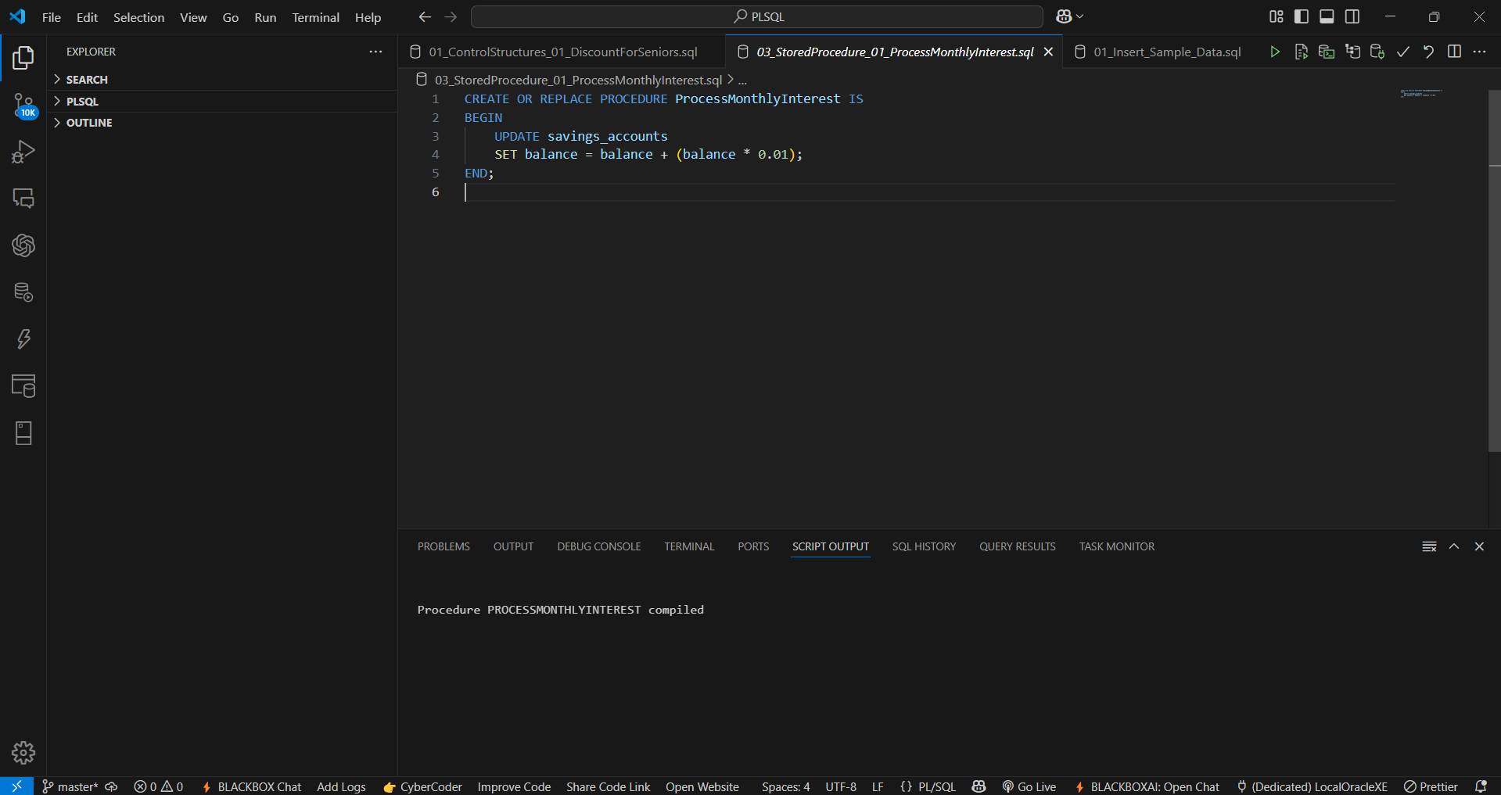

### Scenario 2: Update Employee Bonus

CREATE OR REPLACE PROCEDURE UpdateEmployeeBonus(dept_id IN NUMBER, bonus_pct IN NUMBER) IS  
BEGIN  
 UPDATE employees  
 SET salary = salary + (salary * bonus_pct / 100)  
 WHERE department_id = dept_id;  
END;

## Output

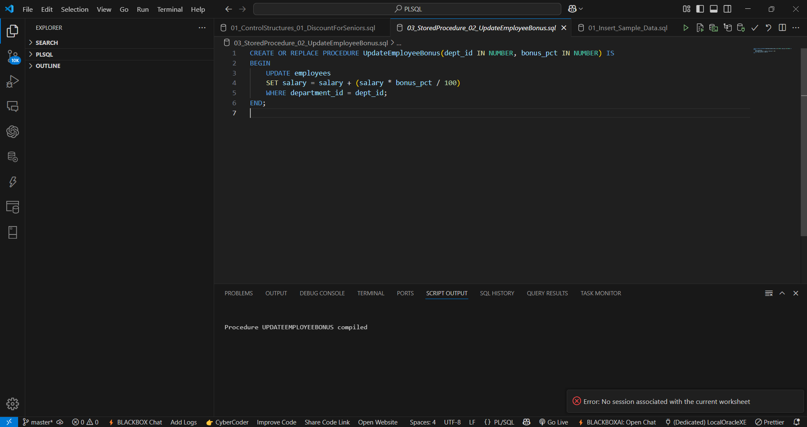

### Scenario 3: Transfer Funds

CREATE OR REPLACE PROCEDURE TransferFunds(from_acct IN NUMBER, to_acct IN NUMBER, amount IN NUMBER) IS  
 insufficient_funds EXCEPTION;  
 balance NUMBER;  
BEGIN  
 SELECT balance INTO balance FROM accounts WHERE account_id = from_acct;  
 IF balance < amount THEN  
 RAISE insufficient_funds;  
 END IF;  
  
 UPDATE accounts SET balance = balance - amount WHERE account_id = from_acct;  
 UPDATE accounts SET balance = balance + amount WHERE account_id = to_acct;  
  
EXCEPTION  
 WHEN insufficient_funds THEN  
 DBMS_OUTPUT.PUT_LINE('Transfer failed: Insufficient funds.');  
END;

## Output

